Junior Numeracy Challenge for December
Balloon Bursting
If a number in one of the balloons is included in the answers to the four problems below then that balloon will fly away.
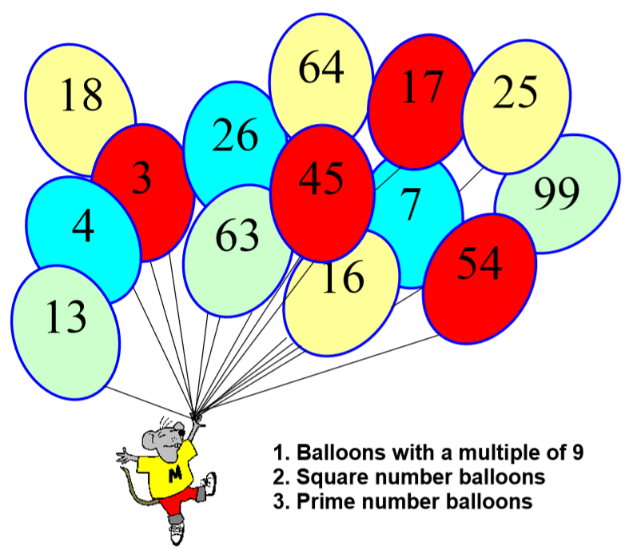

WHICH BALLOON IS LEFT?

